**Week 2: EDA Assignment on the Weather Dataset Analysis cc @channel**  
Perform Exploratory Data Analysis (EDA) to uncover interesting patterns, insights, and potential anomalies within the Weather dataset that we used for week 1 Assignment.  
Please address the following questions and tasks in your analysis:

1. **Data Overview and Cleaning:**
   1. What are the key characteristics of the dataset? (e.g., number of records, features, data types)

Import the needed libraries :

Import pandas as pd

Import numpy as py

Read in the weather dataset

data = pd.read_csv("Weather Data.csv")

read the info of the data. This will give us details of the different attributes in this data, their features, null values and every other summarised details of the data.

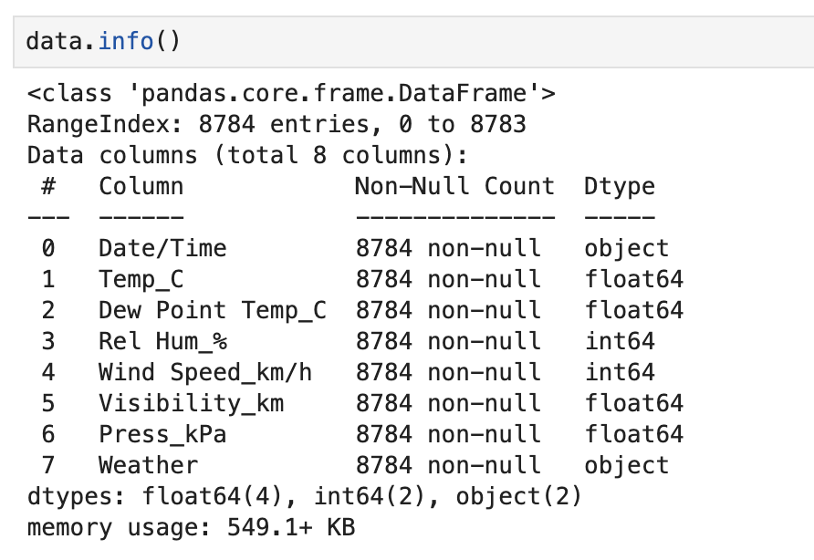

From these results:

we realise none of the fields misses any data.

Float, int and object are the three specific data types across the entire dataset.

The datatset has 8784 records, and eight fields.

* 1. Identify and handle any missing or null values. Describe your approach and reasoning.

To get the missing or null values ,we use the isnull() function found in the pandas library.

Adding the sum() will give us a clear total summary for each record.

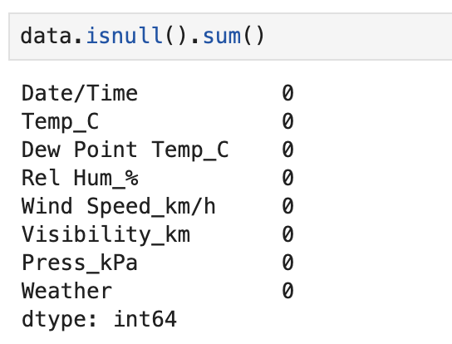

The results of this code shows there are no missing or null values onn this dataset.

* 1. Check for and address any duplicate records.

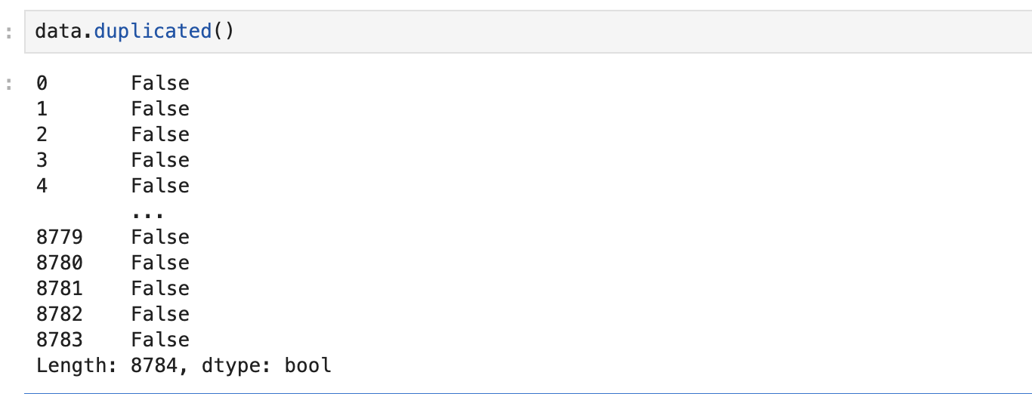

This data has no duplicate values.

1. **Statistical Summary:**
   1. Provide a statistical summary of the dataset (mean, median, standard deviation, etc.) for numerical features.

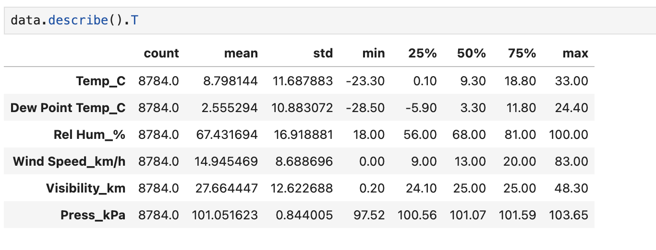

* 1. Identify and describe any significant outliers in the data.

Dew Point Temp_C looks like an outlier because of the very low mean value compared to the rest.

1. **Data Visualization:**
   1. Create visualizations to show the distribution of key weather parameters (e.g., temperature, humidity, wind speed).
   2. Plot time series graphs to visualize trends over time. Highlight any notable patterns or seasonal variations.
   3. Create correlation matrices and heatmaps to identify relationships between different weather parameters.
2. **Weather Patterns and Trends:**
   1. Analyze and describe any trends or patterns you observe in the data. For instance, how do temperature and humidity vary across different seasons or months?
   2. Investigate any anomalies or unusual patterns in the data. What might be the reasons for these anomalies?
3. **Insights and Conclusions:**
   1. Summarize the key insights you have gained from your EDA. What are the most interesting or surprising findings?
   2. How can these insights be useful for weather prediction or other practical applications?
4. **Recommendations for Further Analysis:**

* Suggest areas for further analysis or additional data that might be useful to explore.